3.32: a) Using Eq. (3.31), 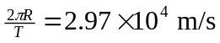. b) Either Eq. (3.30) or Eq. (3.31) gives 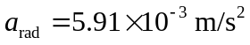. c) 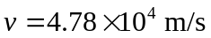, and 

